Subliminal Advertising
- Why is subliminal perception interesting?
  - Fascination with unknown
  - Mind control
  - I can see through this
  - Words or pictures that, while not consciously perceived, may influence a person’s judgments or behaviors on an unconscious level.
  - Such persuasions can be auditory or visual.
  - Load of crap
- EAT POPCORN
  - Vicary and the Popcorn/Coke Study (1957)
    - James Vicary is a market researcher, perhaps best known for popularizing the notion of subliminal advertising in 1957. He claimed that an experiment in which moviegoers were repeatedly shown 0.003-second advertisements for Coca-Cola and popcorn significantly (30%)increased the moviegoers' tendency to purchase popcorn and Coca-Cola over a period of time. No detailed study of his findings was released, however, and no independent evidence turned up to support his claim. Eventually, in 1962, Vicary admitted that the original study was fabricated.
      - In a movie theater, every one of 24 frames, he would put the words “Eat Popcorn, Drink Coke”
    - Unfortunately, many people still believe strongly in subliminal advertising. The following slides are examples caused controversy after 1962, when Vicary admitted the whole thing was a hoax to spark his advertising business.
    - Later admitted to fabricating research
  - Wilson Bryan Key: wrote a lot of books about subliminal advertising, said subliminal advertising was taking over our culture (popular in the 70s and 80s)
    - Clam Plate Orgy: book he wrote
    - Tried pointing out these ridiculous images of sex in advertising, like a thing of fried clams is people having an orgy

  - How does this picture affect you?
  - Is the message visible? Can you ignore it once you recognize it?
  - If you saw someone wearing this, would your attitude about the person change?
- Bush's campaign ad
  - Republican presidential nominee George W. Bush said Tuesday he was "convinced" an ad placed by the Republican National Committee that flashes the word "RATS" over a Gore prescription drug proposal was not intended to send a subliminal message.
  - People still believe this advertising actually works
- Do you suddenly want to walk a mile for a Camel? People say there is a naked man on the camel for camel cigarettes
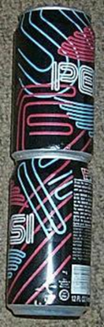
  - Sexual images are fairly common in subliminal advertising. However, is it true that sex sells things?
  - Would seeing the silhouette of an unclothed person make you want to buy cigarettes?
- Some people argued that this was greated by careful planning on the part of Pepsi.
Pepsi said this was a coincidence

- A Unique Constellation
  - The story is that a 4 year old child saw the word “sex” in the stars of the Lion King. The story is unverified as many 4 year olds cannot read, not do many understand what sex is. The alternate story is that this is SFX (short for special effects). Because people in Disney don’t get their name on the piece of work, it’s under the Disney name, so workers will slide stuff in?
- Rated G?
  - 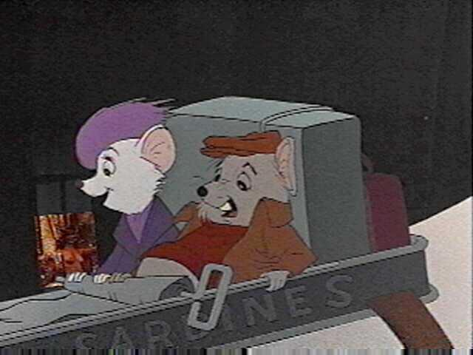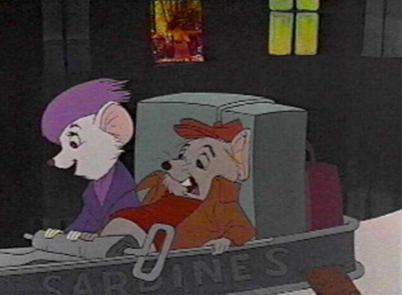
  - Sometimes the rumors are true. Disney’s the Rescuers was pulled from VHS shortly after its release. Before the advent of VHS, many inside pranks could be hidden within a film. Such pranks became more apparent when people were able to use a “pause” and “slow motion” feature.
- Advertisements/movie summary:
  - Naked man on Camel Cigarettes, Sex spelled when connect the dots on Ritz Crackers, Sex on Pepsi cans, Bush Campaign “Rats”
  - Disney Subliminal Messages
  - Lion King- SEX in the stars
  - The Rescuers – Topless woman in the window
  - Little Mermaid – Minister boner
  - Aladdin – “Take off your clothes”
  - Original Little Mermaid Cover – penis on the castle
  - Star Wars C-3PO Trading Card – penis
  - Yellow Pages – flooring advisement, women masturbating
  - Wizard of Oz – Hanging munchkin
- Does it Work?
  - Does the word “sex” make you want to buy toothpaste?
  - No, more direct advertising actually works better
  - Ads are most effective if the audience can perceive and understand the message
  - Come up with a brainstorming list, and subilimaral told a word you might say that word
- Do it!
  - Judas Priest was a British heavy metal rock band-one of the first of that genre. Their popularity peaked in the mid-70s. The album in question (Stained Class) was produced in 1978; the shootings took place in December 1985. It was alleged that a particular subliminal phrase in one of their songs ("Better by You Better Than Me") on the album triggered a suicidal impulse. The phrase at issue was "Do It." In isolation, this phrase has little meaning unless there is some antecedent to which the "It" refers. Moreover, the antecedent could not have been anything that was audible on the record (or visible on the album cover), because such material would have been protected by the First Amendment. Consequently the plaintiffs were in the difficult position of having to acknowledge that the boys were suicidal to begin with, and that the subliminal phrase "Do It" triggered the already existing disposition.
  - Case was dismissed
- What does this mean for us?
  - Everyday subliminal: shown not to work
    - Subliminal tapes
      - Subliminal messages have more of a placebo effect: self-help tapes
  - Controlled studies
    - Pairing faces with an image
    - Subliminal persuasion does have some effect: pairing faces with an images
  - Ads are most powerful when we perceive them
  - Subliminal vs. Subtle: theres a difference
    - *no evidence supports subliminal messages can influence every behavior
    - *when tapes were used, the labels were switched and most people said they had a change in behavior. Placebo effect

